**Getting Started with Python in VS Code**

Prerequisites:

First, we need to first setup Python development environment. Specifically, we need the following.

1. Python
2. VS Code
3. VS Code Python extension.

# Installing a Python interpreter:

Install the latest version that appears first on the page [Python from python.org](https://www.python.org/) .

To verify that Python has been installed on your machine, run the following command.

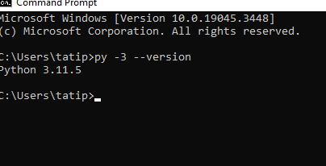

## Start VS Code in a workspace folder.

By starting VS Code in a folder, that folder will be your “workspace”. you can create a folder through the operating system UI, then use VS Code's **File > Open Folder** to open the project folder.

## [Create a virtual environment](https://code.visualstudio.com/docs/python/python-tutorial#_create-a-virtual-environment)

Go to [Please refer to create a virtual environment in the Getting Started with Python in VS Code](https://code.visualstudio.com/docs/python/python-tutorial#_install-and-use-packages)

## Miscellaneous links:

stack overflow:

https://stackoverflow.com/questions/54776324/powershell-bug-execution-of-scripts-is-disabled-on-this-system

python extension for Visual code: https://marketplace.visualstudio.com/items?itemName=ms-python.python